**IST 370**

**Lab Assignment 3 (25 points)**

Theme: Basic SELECT Statements

*** IMPORTANT ***

To verify that all of your SQL scripts are valid and working, you should submit a WORD document with necessary screenshots that include your SQL scripts along with corresponding query results. Insert pertinent screenshot(s) under each question. (Note: Submission of only image files (e.g., jpg or png) or Notepad files is NOT ACCEPTABLE. It will be returned for resubmission.)

all submissions Without compliance with the instructions will be retruned.

Example for your lab assignment submission:

**Question: Create a list that displays the title of each book and the name and phone number of the contact at the publisher‘s office for reordering each book.**

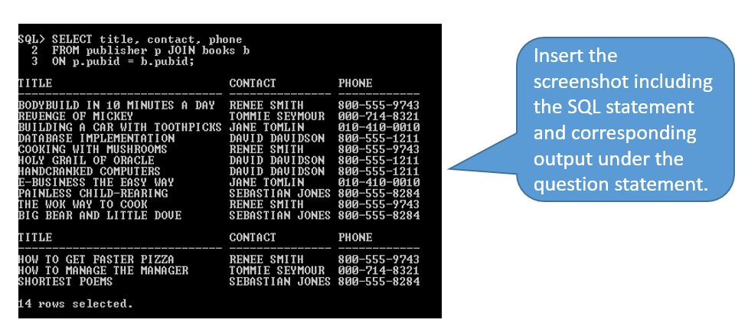

What to do first?

First copy and paste the SQL statements (listed in the Notepad++ file, titled “LAB_DATASOURCE_IST370.sql”) onto the Run SQL Command Line program to create all the tables and insert sample rows.

**PROBLEMS**

You are to use a more complete database as the data source and write corresponding SELECT statements to address various user requests. The SQL code for creating those tables with necessary constraints and inserting sample rows are provided in a separate file.

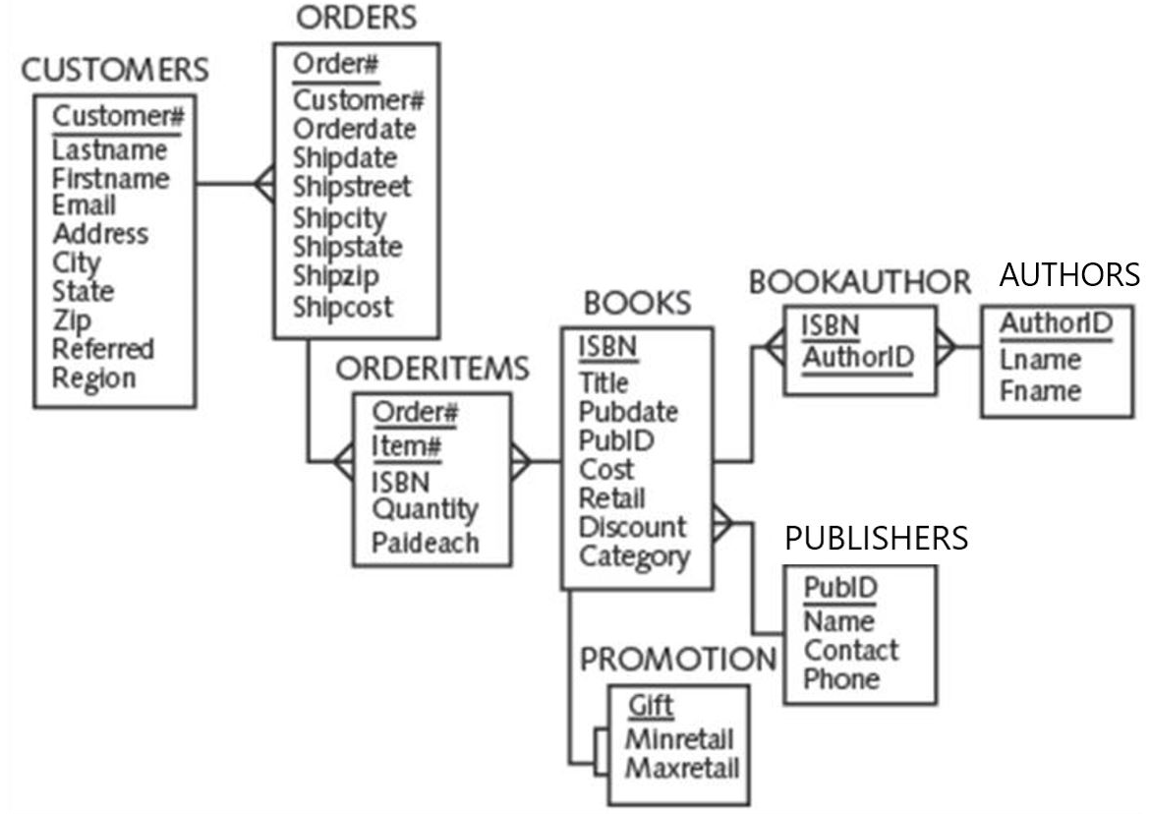

**Write a corresponding SELECT statements to address each of the following user requests. (The query result produced should look like the one included under each question.)**

1. List the title and publication date for each book in the BOOKS table. Use the column heading “Book Title” for the title field and “Publication Date” for the Pubdate field. Sort the result in ascending order of publication date. The query result is shown as below:

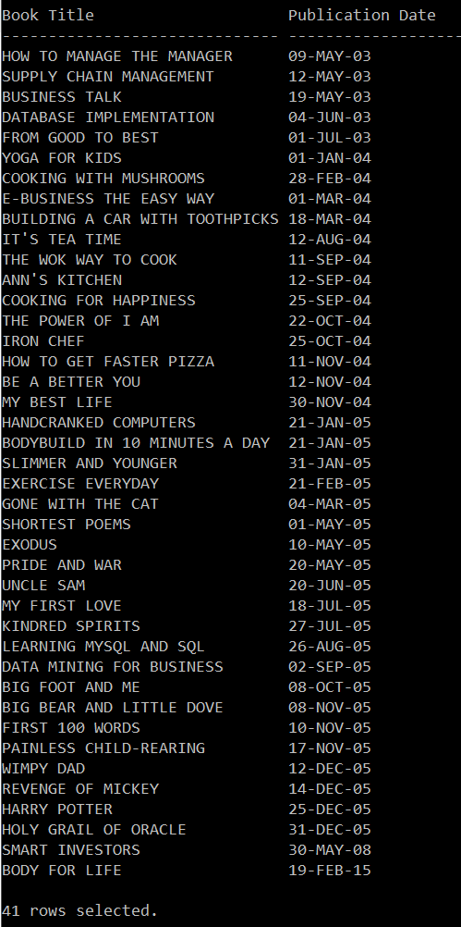

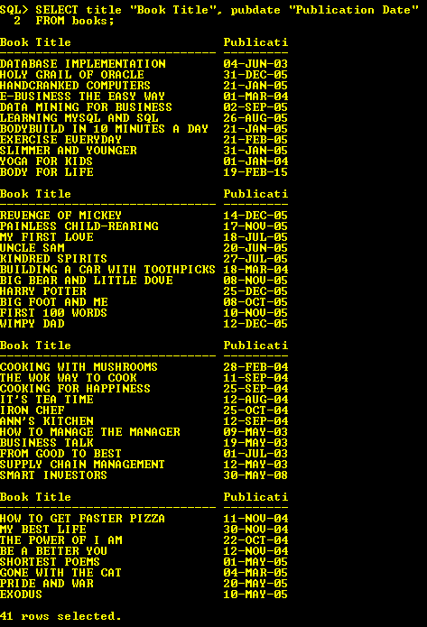

1. Find out distinct categories published by distinct publishers. Sort the result in ascending order of pubid.

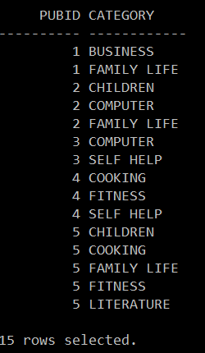

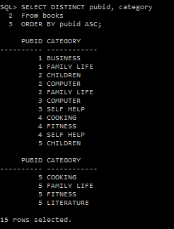

1. List all information for each order item (ORDER#, ITEM#, ISBN, QUANTITY, and PAIDEACH). Also include an item total, which can be calculated by multiplying the Quantity and Paideach columns. Use a column alias for the calculated value to show the heading “ITEM TOTAL” in the output. Sort the output in descending order of ITEM TOTAL.

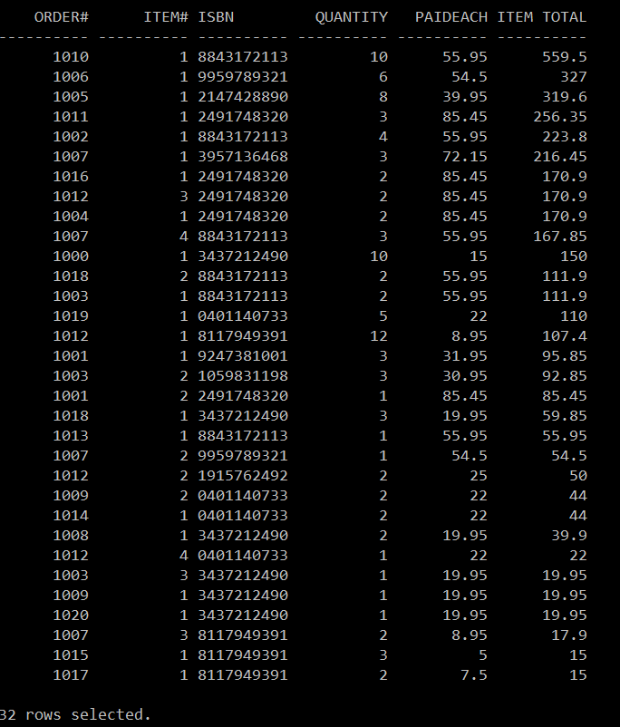

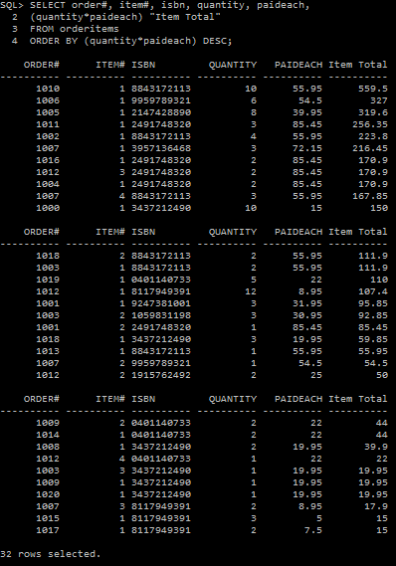

1. Create a mailing list from the CUSTOMERS table. The mailing list should display the name, address, city, state, and zip code for each customer. Each customer’s name should be listed in order of last name followed by first name, separated with a comma, and have the column header “Name.” The city and state should be listed as one column of output, with the values separated by a comma and the column header “Location.” Sort the output in descending order of last name.

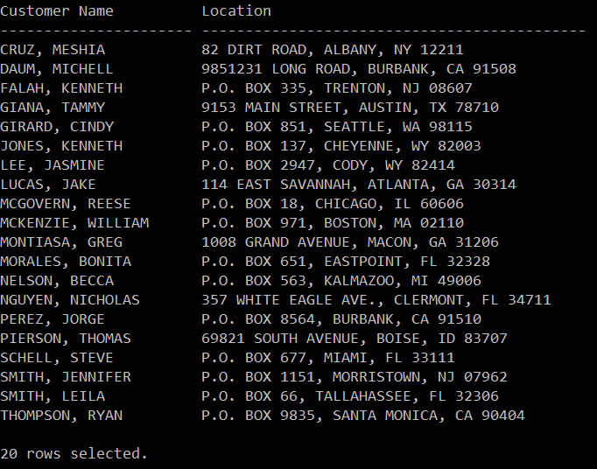

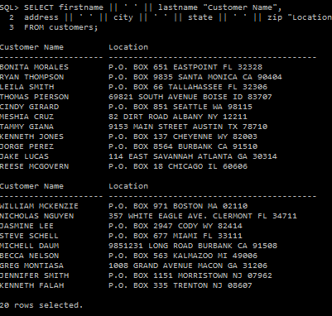

1. Use a SELECT statement to display each book’s title and percentage of profit. Use "Book Title" as the column heading for book's title. For the column displaying the percentage markup, use “Profit %” as the column heading.

To determine the percentage of profit for a particular item, subtract the item’s cost from the retail price to calculate the dollar amount of profit, and then divide the profit by the item’s cost. The solution is then multiplied by 100 to determine the profit percentage for each book: (retail-cost)/cost*100

Sort the output in ascending order of “Profit %.”